**Classroom Activity​: Write a program to Print number from 5-10 using do while loop**

**​**

**Code-**

​

**Output-**

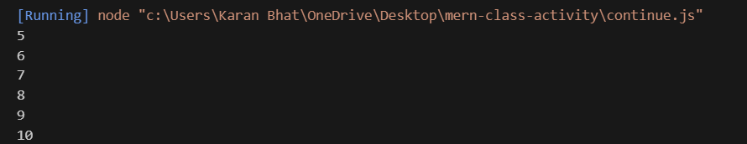

**Execution-Steps:**

* Create a JavaScript file with any name
* Write the code
* Run the code in the terminal using F5 or right click and go to inspect and you can get the output in the console as well.